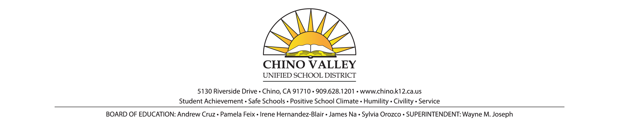**PRESS RELEASE**

**FOR IMMEDIATE RELEASE** **CONTACT**: Imee Perius, Director of Communications

January 26, 2018 (909) 628-1201 ext. 1616, *OR*

Brenda Dunkle, Multi Media Communications Specialist

(909) 628-1201 ext. 1617

**New Chino Valley Unified School District Children’s Health Center Satellite Clinic Open for Students with Government Subsidized or No Health Insurance**

***Health Center and Satellite will Continue to Provide Flu Shots***

Chino Hills, CA.—The Chino Valley Unified School District (CVUSD) Children’s Health Center satellite clinic opened on January 25, 2018, offering CVUSD students with no insurance or government subsidized insurance with immunizations, including the flu shot, physical exams, illness care and assistance with Medi-Cal approval. The satellite CVUSD Children’s Health Center is located in the HOPE (Helping Our People Everyday) Room at the CVUSD Alternative Education Center at 15650 Pipeline Ave., Chino Hills. Health Center hours are 9:00 a.m. to noon on February 1 and 22, and March 1 and 22, 2018. Expanded operation hours are being determined and will be announced at that time.

The Health Center’s expansion is being funded by a $10,000 grant from the City of Chino Hills with an eye towards assisting families that live in the Los Serranos area of Chino Hills.

CVUSD’s Children’s Health Center opened in 2007 and is located at the Chino Valley Adult School campus, 12970 Third St., Chino.

Both health centers offer health services to children and students ages 0 to 21. Patients are encouraged to make appointments by calling (909) 628-1201 ext. 8935.

# # #